Project Design Phase
Solution Architecture
Date | 01 October 2026
Team ID | SWTID-2026-8643
Project Name | Script-Controlled ACL - Restrict Record Access Based on Field Value
Maximum Marks | 4 Marks
Solution Architecture:
Solution architecture connects the business problem with an appropriate technology solution.Solution architecture bridges the gap between business problems and technology solutions. For this project, the
For this project, the challenge is unrestricted access to student records, while the solution
uses a layered, role-based and script-controlled ACL design on the ServiceNow platform. Its goals are to:problem is unrestricted access to student records, and the solution is a layered, role-based and script-controlled
ACL design built on the ServiceNow platform. Its goals are to:
? Identify an effective technology solution for the business problem: restrict record access by field value (Branch) and by role.• Find the best tech solution to solve the business problem: restrict record access by field value (Branch) and by role.
? Explain the structure, characteristics and behavior of the solution to project stakeholders.• Describe the structure, characteristics and behavior of the solution to project stakeholders.
? Define the features, development stages and solution requirements.• Define features, development phases and solution requirements.
? Provide specifications through which the solution is defined, managed and delivered.• Provide specifications according to which the solution is defined, managed and delivered.
Solution Architecture Diagram:
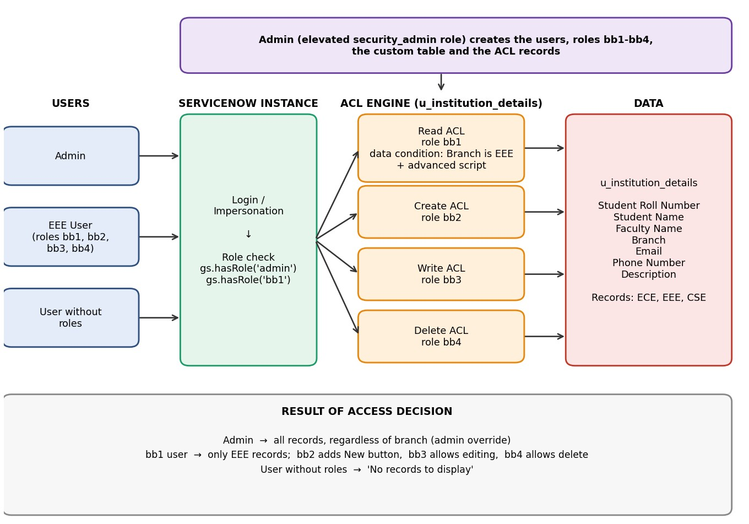
Figure 1: Architecture and data flow of the script-controlled ACL solution

Components

Component Description
Users and Roles EEE User with custom roles bb1 (Read), bb2 (Create), bb3 (Write) and bb4 (Delete); AdminEEE User with custom roles bb1 (Read), bb2 (Create), bb3 (Write) and bb4 (Delete); Admin with the admin role (and security_admin elevated for ACL configuration). with the admin role (and security_admin elevated for ACL setup).
Custom Table u_institution_details with fields Student Roll Number (auto number), Student Name, Facultyu_institution_details with fields Student Roll Number (auto number), Student Name, Faculty
Name, Branch (ECE, EEE, CSE), Email, Phone Number and Description. Name, Branch (ECE, EEE, CSE), Email, Phone Number and Description.
ACL Engine Four record-type ACLs on the table, one per operation (read, create, write, delete). The ReadFour record-level ACLs on the table, one for each operation (read, create, write, delete). The Read
ACL is advanced: data condition 'Branch is EEE' together with a script using gs.hasRole(). ACL is advanced: data condition 'Branch is EEE' plus a script using gs.hasRole().
Verification Impersonation of the EEE user, a user without roles, and Admin, then opening the table listImpersonation of the EEE user, a user without roles, and Admin, followed by opening the table list
(u_institution_details.list).
(u_institution_details.list).

Data Flow
11. Admin elevates to security_admin and creates the users, roles bb1-bb4, the table u_institution_details and sample records.. Admin elevates to security_admin and creates the users, roles bb1-bb4, the table u_institution_details and sample records.
22. Admin creates the Read, Create, Write and Delete ACLs, with each ACL requiring its assigned role.. Admin creates the Read, Create, Write and Delete ACLs, each requiring its own role.
33. A user signs in (or is impersonated) and opens the table list.. A user logs in (or is impersonated) and opens the table list.
44. ServiceNow checks the user's roles with gs.hasRole() and evaluates the ACL for each operation.. ServiceNow checks the user's roles with gs.hasRole() and evaluates the ACL for each operation.
55. The Read ACL checks the record's Branch value against the data condition (Branch is EEE) and executes the advanced script.. The Read ACL checks the record's Branch value against the data condition (Branch is EEE) and runs the advanced script.
66. The result is returned: permitted records are shown, while denied records remain hidden from the list and form.. The result is returned: allowed records are shown and denied records are hidden from the list and form.

Access Matrix
User / Role | Read | Create | Write | Delete
Admin | All records | Yes | Yes | Yes
bb1 | Only EEE records | No | No | No
bb1 + bb2 | Only EEE records | Yes (New button) | No | No
bb1 + bb2 + bb3 | Only EEE records | Yes | Yes (edit) | No
bb1 + bb2 + bb3 + bb4 | Only EEE records | Yes | Yes | Yes
No roles | No records to display | No | No | No
Reference: ServiceNow Access Control (ACL) documentation, System Security module.

